

University of Petroleum &

Energy Studies

# SCHOOL OF COMPUTER SCIENCE

**Name**: Nancy Gumanta **Course**: BTech CSE **SAP ID**: 500121761

**BATCH**: 2

**PRESENTED TO**: Dr. Syed Sajid Hussain

**Semester**: 3

# Experiment 17: To understand the concepts of Trigger.

**Objective:** Students will be able to implement the concept of trigger.

1. CREATE TRIGGER SALARY_VIOLATION BEFORE INSERT OR UPDATE OF SALARY, SUPERVISOR_SSN ON EMPLOYEE of experiment 3.

INPUT:

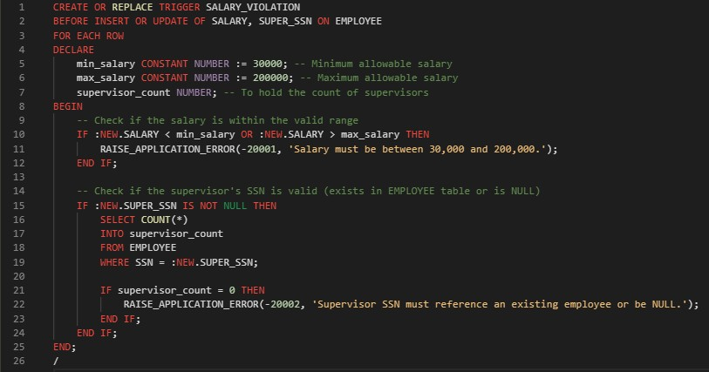

Valid Insert:

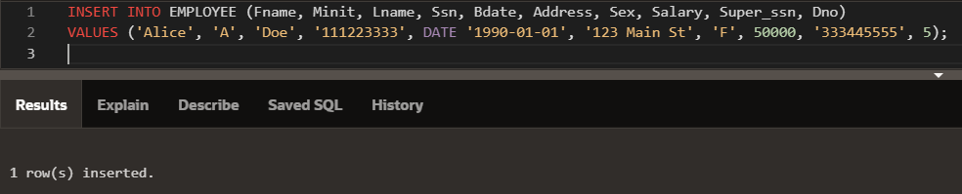

Invalid Insert:

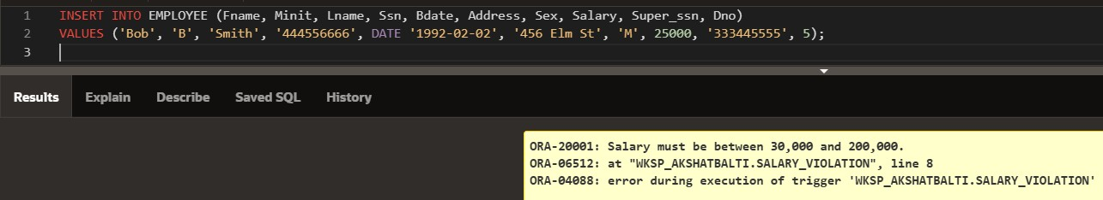

Invalid Update:

